**Hive Custom UDF to parse User Agent**

**Hive**

Hive gives a SQL-like interface to manage data. It is used in Amazon H3 file system. It also support HiveQL. Hive implicitly codeword hiveQL statement into Adirected acyclic graph of mapreduce those the spark jobs.

It support Advance features such as indices, partition, buckets, asummetric transactions, custom user defined functions, joins, sampling & many others. Lots of them take a considerable amount of time if implemented manually.

**Adding Jar to HIVE**



**Create table in hive**



**Load Data into table**

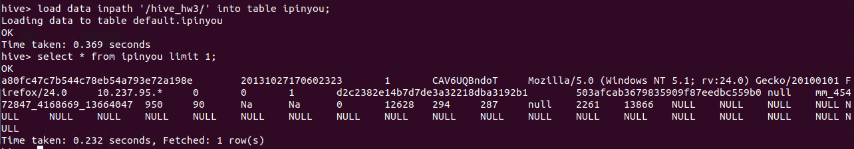

**Create Temporary function**



**Output**

